**C++ assignment**

Q-1 What are the key differences between Procedural Programming and Object-Oriented Programming (OOP)?

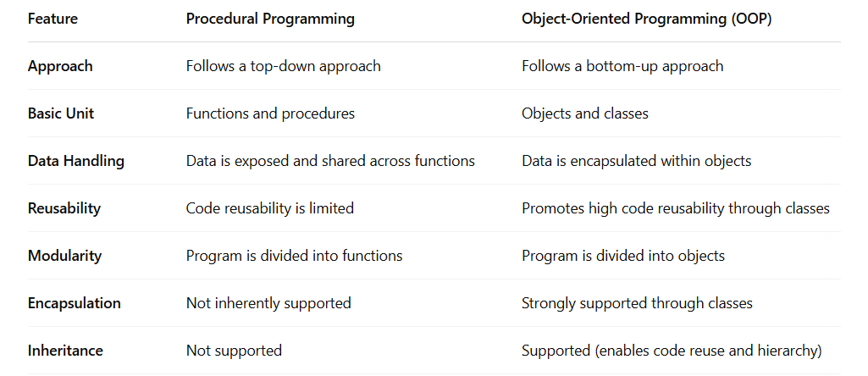

Q-2 List and explain the main advantages of OOP over POP.

A-2

**1. Modularity**

* **OOP**: Code is organized into classes and objects, which helps in breaking down complex problems into smaller, manageable parts.
* **Advantage**: Easier to understand, test, and maintain each part independently.

**2. Reusability**

* **OOP**: Allows reuse of existing code through **inheritance**. You can create new classes by inheriting features from existing ones.
* **Advantage**: Saves time and effort, avoids redundancy.

**3. Encapsulation**

* **OOP**: Keeps data and related functions together inside objects, hiding the internal details using **access modifiers** (private, protected, public).
* **Advantage**: Enhances security and data integrity by restricting unauthorized access.

**4. Inheritance**

* **OOP**: Enables one class (child) to inherit properties and behaviors from another class (parent).
* **Advantage**: Promotes code reuse and establishes a natural hierarchy.

**5. Polymorphism**

* **OOP**: Allows functions or methods to behave differently based on the object calling them (method overloading/overriding).
* **Advantage**: Flexibility and ease in maintaining and updating code.

**6. Abstraction**

* **OOP**: Shows only essential features to the user and hides the complex implementation details.
* **Advantage**: Reduces complexity and increases efficiency.

**7. Better Data Management**

* **OOP**: Data is tied to objects and manipulated only through methods.
* **Advantage**: Makes it easier to model real-world scenarios, improving the structure and reliability of the program.

**8. Easier Maintenance and Upgrades**

* **OOP**: Changes in one class usually do not affect other parts of the program.
* **Advantage**: Enhances maintainability, especially in large-scale applications.

**9. Real-world Modeling**

* **OOP**: Objects represent real-world entities like "Car", "Employee", etc.
* **Advantage**: Makes design more intuitive and close to human thinking.

Q-3 Explain the steps involved in setting up a C++ development environment.

A-3 **1. Install a C++ Compiler**

A compiler translates C++ source code into machine code. Without it, you can't run your programs.

* It is essential to install a compatible C++ compiler (like GCC, Clang, or MSVC) depending on your operating system.

**2. Choose a Code Editor or IDE**

An **Integrated Development Environment (IDE)** or code editor is used to write, edit, and manage your C++ code easily.

* IDEs like Visual Studio, Code::Blocks, or CLion offer tools like syntax highlighting, auto-completion, and debugging support.

**3. Configure the Editor/IDE**

The code editor or IDE must be configured to recognize the installed compiler.

* This step involves setting paths and build tasks so that code can be compiled and executed directly within the editor.

**4. Write a Simple Program**

Once the environment is ready, you write a basic C++ program (commonly called a "Hello World" program) to test the setup.

* This step ensures that the compiler and IDE/editor are correctly configured.

**5. Compile the Program**

The source code is compiled using the compiler, which checks for syntax errors and converts the code into an executable file.

* This step confirms that the environment is functional.

**6. Run and Debug**

You execute the compiled program to see the output. Debugging tools in the IDE can help identify and fix errors.

**7. Optional: Version Control Integration**

You can integrate version control tools like Git to manage your code versions, collaborate, and track changes.

Q-4 What are the main input/output operations in C++? Provide examples.

A-4 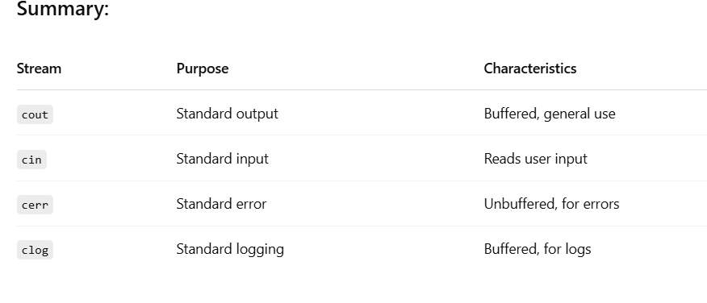

Q-5 What are the different data types available in C++? Explain with examples.

A-5 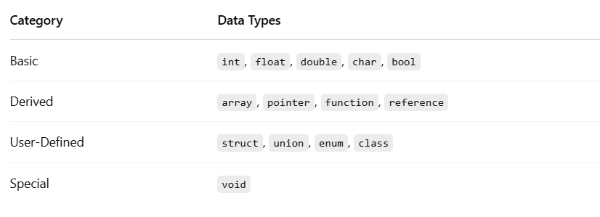

Q-6 Explain the difference between implicit and explicit type conversion in C++.

A-6

**Definition:**

Implicit type conversion is **automatically performed by the compiler** when different data types are mixed in an expression.

**Key Points:**

* Happens **without the programmer’s intervention**.
* Converts smaller data types to larger ones (e.g., int to float).
* Helps in preventing data loss in mixed-type expressions.

**Example (Conceptual):**

When you add an int and a float, the compiler converts the int to a float automatically.

**2. Explicit Type Conversion (Type Casting)**

**Definition:**

Explicit type conversion is **done manually by the programmer** using casting syntax. **Key Points:**

* The programmer tells the compiler to convert a value from one data type to another.
* Useful when you want **full control** over type conversion.
* Can lead to data loss if not done carefully.
* **Example (Conceptual):**

If you want to convert a float to an int to remove decimal places, you use casting.

Q-7 What are the different types of operatorsin C++? Provide examples of each.

A-7 **1. Arithmetic Operators**

Used to perform basic mathematical operations.

* **Operators**: +, -, *, /, %
* **Example (Conceptual)**: Used to add two numbers or find the remainder.

**2. Relational (Comparison) Operators**

Used to compare two values.

* **Operators**: ==, !=, >, <, >=, <=
* **Example (Conceptual)**: Check if two numbers are equal or if one is greater than another.

**3. Logical Operators**

Used to combine multiple conditions.

* **Operators**: && (AND), || (OR), ! (NOT)
* **Example (Conceptual)**: Check if both conditions are true or at least one is true.

**4. Assignment Operators**

Used to assign values to variables.

* **Operators**: =, +=, -=, *=, /=, %=
* **Example (Conceptual)**: Add and assign a value to a variable.

**5. Increment and Decrement Operators**

Used to increase or decrease a variable’s value by 1.

* **Operators**: ++ (increment), -- (decrement)
* **Example (Conceptual)**: Increase a counter in a loop.

**6. Bitwise Operators**

Used to perform operations at the binary level.

* **Operators**: &, |, ^, ~, <<, >>
* **Example (Conceptual)**: Perform binary AND or shift bits to the left/right.

**7. Conditional (Ternary) Operator**

Used to choose between two values based on a condition.

* **Operator**: ? :
* **Example (Conceptual)**: Select one of two values depending on a condition.

**8. Sizeof Operator**

Used to determine the size (in bytes) of a data type or variable.

* **Operator**: sizeof
* **Example (Conceptual)**: Find out how many bytes an int occupies.

**9. Typecast Operator**

Used to convert one data type into another.

* **Operator**: (type)
* **Example (Conceptual)**: Convert a float to an int.

**10. Scope Resolution Operator**

Used to define a function or variable outside its class or namespace.

* **Operator**: ::
* **Example (Conceptual)**: Access a global variable hidden by a local one.

Q-8 Explain the purpose and use of constants and literals in C++.

A-8 **Purpose:**

Constants are used to **store fixed values** that **do not change** during program execution. They help make programs more **readable**, **maintainable**, and **less error-prone**.

**Benefits of Constants:**

* **Prevents accidental modification** of values.
* **Improves code clarity** by giving meaningful names to fixed values.
* Helps with **program maintenance** (easy to update in one place).

Q-9 What are conditional statements in C++? Explain the if-else and switch statements.

A-9

**1. if-else Statement:**

* The if-else statement is used to make decisions in C++. It checks a condition and executes one block of code if the condition is true, and another block if the condition is false.
* **Usage**: It allows the program to choose between two possible actions based on a condition.

**2. switch Statement:**

* The switch statement is used when you need to choose between many possible outcomes based on the value of a single expression.
* It compares the expression with multiple possible values and executes the corresponding block of code when a match is found. It is often more efficient than using multiple if-else statements when dealing with multiple values.

Q-10 What is the difference between for, while, and do-while loops in C++?

A-10

**1. for Loop:**

* The for loop is used when the **number of iterations is known beforehand**. It allows you to initialize a loop counter, define a condition to continue looping, and specify how to modify the loop counter after each iteration (e.g., increment or decrement).
* **Usage**: Best suited for counting or iterating a fixed number of times.

**2. while Loop:**

* The while loop is used when the condition needs to be checked **before** entering the loop. It continues as long as the specified condition evaluates to **true**.
* **Usage**: Ideal when the number of iterations is **not known beforehand** and depends on runtime conditions, like reading user input or checking dynamic conditions.

**3. do-while Loop:**

* The do-while loop is similar to the while loop but with the difference that the **condition is checked after** the loop executes. This guarantees that the loop will run **at least once**, regardless of the condition.
* **Usage**: Useful when you need the loop to execute at least once, such as prompting a user for input and validating it after the first attempt.

Q-11 How are break and continue statements used in loops? Provide examples.

A-11

**break Statement**

* **Purpose**: The break statement is used to **exit** a loop prematurely, regardless of the loop's condition. Once break is executed, the program control exits the loop, and the code following the loop is executed.
* **Usage**: Typically used when a specific condition is met, and there's no need to continue looping.

**continue Statement**

* **Purpose**: The continue statement is used to **skip the current iteration** of the loop and proceed to the next iteration. It does not terminate the loop; instead, it causes the loop to **jump to the next iteration**, checking the condition again.
* **Usage**: Commonly used to skip over certain iterations based on a condition without terminating the loop.

Q-12 Explain nested control structures with an example.

A-12

**Nested if Statements**:  
An if statement placed inside another if or else statement. This allows for multiple conditions to be checked within the same logic.

**Nested Loops**:  
A loop inside another loop. This is often used for iterating over multi-dimensional data structures like matrices or performing repeated actions within repeated actions.

**Combination of if and Loops**:  
A combination of conditional statements and loops, where a loop contains an if statement, or vice versa. This is useful when you need to check conditions during iterations.

Q-13 What is a function in C++? Explain the concept of function declaration, definition, and calling

A-13

A **function** in C++ is a block of code that performs a specific task. It allows you to group statements and reuse them in different parts of a program. Functions help in making programs **modular**, **organized**, and **easy to maintain** by breaking down complex problems into smaller, manageable parts.

**Concept of Function Declaration, Definition, and Calling**

**1. Function Declaration (Prototype):**

* A function declaration provides the **function's signature** (name, return type, and parameters) to the compiler before it is used. It tells the compiler about the function's return type, name, and how many arguments it takes, but **does not define the function's body**.

Q-14 What is the scope of variables in C++? Differentiate between local and globalscope.

A-14

**Scope of Variables in C++**

The **scope** of a variable defines the **region of the program** where the variable can be accessed. C++ provides different types of variable scope based on where a variable is declared.

**Local Scope**

* A **local variable** is declared inside a function or a block of code.
* It can only be accessed within the function or block in which it is declared.
* The **lifetime** of a local variable is limited to the execution of the function or block.

**Global Scope**

* A **global variable** is declared outside all functions, usually at the top of the program.
* It can be accessed by any function in the program.
* The **lifetime** of a global variable lasts for the entire duration of the program.

**Key Differences Between Local and Global Scope**

* **Local Variables**:
  + Declared inside a function/block.
  + Accessible only within that function/block.
  + Exist only during the function/block execution.
* **Global Variables**:
  + Declared outside any function.
  + Accessible throughout the entire program.
  + Exist for the entire duration of the program.

Q-15 Explain recursion in C++ with an example

A-15

**Recursion in C++**

Recursion is a process in which a function calls itself in order to solve a problem. It is a powerful technique used to break down complex problems into simpler sub-problems.

A recursive function generally consists of two main components:

1. **Base Case**: The condition that terminates the recursion. This is crucial to prevent the function from calling itself indefinitely.
2. **Recursive Case**: The part of the function that calls itself with modified arguments, gradually moving towards the base case.

**How Recursion Works**

* The function calls itself with a modified argument or parameters.
* This process continues until the base case is met.
* Once the base case is reached, the recursion stops, and the function begins returning values back to the previous calls.
* The results are combined as the recursive calls "unwind," and the final result is produced.

**Example: Factorial Calculation**

The **factorial** of a number n is calculated as the product of all positive integers less than or equal to n. The factorial function can be defined recursively as:

* Base Case: factorial(0) = 1
* Recursive Case: factorial(n) = n * factorial(n - 1)

**Advantages of Recursion:**

* **Simplifies Complex Problems**: Recursion is often easier to understand and implement for problems with repetitive or hierarchical structures, such as searching trees or calculating factorials.
* **Elegant Solution**: Recursive solutions are often cleaner and more intuitive for certain types of problems.

**Disadvantages of Recursion:**

* **Memory Usage**: Each recursive call adds a new frame to the call stack, which can lead to **stack overflow** for deep recursion.
* **Performance Overhead**: Recursive functions can be slower and more memory-intensive compared to iterative solutions, especially when the recursion depth is large.

Q-16 What are function prototypes in C++? Why are they used?

A-16

**Provide Function Information to the Compiler**:

* The function prototype tells the compiler about the function's return type, name, and parameters before the function is called, allowing for proper type checking.

**Enable Calling Functions Before Definition**:

* Prototypes allow functions to be called in main() or other functions before their full definition appears in the code.

**Ensure Correct Function Calls**:

* The prototype ensures that the function is called with the correct number and types of arguments, preventing errors in the program.

**Improve Code Organization**:

* Function prototypes help in organizing the code, making it easier to read and maintain by separating function declarations from the implementation.

Q-17 What are arrays in C++? Explain the difference between single-dimensional and multidimensional arrays.

A-17

**Arrays in C++**

An **array** in C++ is a collection of elements of the **same type**, stored in **contiguous memory locations**. Arrays allow storing multiple values under a single variable name, which can simplify code and data management.

* **Fixed Size**: Arrays in C++ have a **fixed size** that must be specified during the declaration. The size cannot be changed once the array is created.
* **Indexing**: Elements in an array are accessed using indices, starting from 0 for the first element, 1 for the second, and so on.

**Single-Dimensional Arrays**

A **single-dimensional array** (1D array) is a simple list of elements that all belong to the same data type.

* It is declared with a single index representing the size of the array, and all elements can be accessed by specifying the index.

**Multidimensional Arrays**

A **multidimensional array** is an array of arrays. It allows for the storage of data in more than one dimension, such as a table with rows and columns.

* The most common example of a multidimensional array is a **two-dimensional array** (2D array), but C++ also supports arrays with three or more dimensions.

**Difference Between Single-Dimensional and Multidimensional Arrays**

* **Single-Dimensional Array**: Stores a sequence of elements that can be accessed with one index.
* **Multidimensional Array**: Stores data in multiple dimensions (e.g., a table), where each element requires multiple indices to access.

Q-18 Explain string handling in C++ with examples.

A-18

**String Functions**: In C++, C-style strings can be manipulated using standard functions from the C library, such as:

* strlen(): Determines the length of the string.
* strcpy(): Copies one string to another.
* strcat(): Concatenates two strings.
* strcmp(): Compares two strings.

**Concatenation**: The + operator can be used to concatenate strings.

**Length**: The .length() or .size() function gives the number of characters in the string.

**Access**: Characters in a string can be accessed using the [] operator or .at().

**Substring**: The .substr() method extracts a part of the string.

**Search**: The .find() method searches for a substring within the string.

Q-19 How are arraysinitialized in C++? Provide examples of both 1D and 2D arrays.

A-19  **Array Initialization in C++**

In C++, arrays can be initialized in various ways, both at the time of declaration and afterward. Initialization ensures that the array elements are set to valid values before use.

**1D Array Initialization**

A **1D array** (single-dimensional array) is a collection of elements of the same type. Arrays can be initialized in the following ways:

**2D Array Initialization**

A **2D array** (two-dimensional array) is an array of arrays, used to represent data in a tabular format (rows and columns). Initialization is similar to 1D arrays but requires nested braces {} for the rows and columns.

Q-20 Explain string operations and functionsin C++.

A-20 **✅ String Operations and Functions in C++**

In C++, strings can be managed using either **C-style strings** (character arrays) or the more modern **C++ std::string class** from the Standard Library. The std::string class provides various operations and functions that make string handling easier and safer than C-style strings. Below, we focus primarily on std::string operations and functions.

**String Operations Using std::string**

The **std::string** class provides a wide range of built-in functions to perform various string operations such as concatenation, modification, comparison, and searching.